

Sample Pentest Report

Security Assessment Findings Report

Project: Sample Pentest Report

Date: 10 July-10 December 2024

Reporter: John Doe

**Table of Contents**

Executive Summary 2

Technical Summary 2

Vulnerabilities 4

1. SQLi 4

# Executive Summary

Executive Summary.

# Technical Summary

|  |  |  |  |  |  |
| --- | --- | --- | --- | --- | --- |
| **Findings** | | | | | |
| **Critical** | **High** | **Medium** | **Low** | **Informational** | **Total** |
| 1 | 0 | 0 | 0 | 0 | 1 |

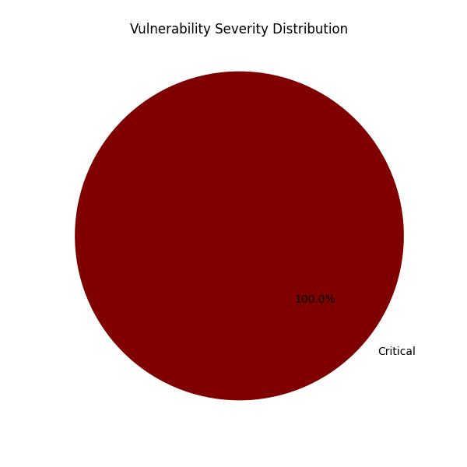

# Vulnerabilities

## 1. SQLi

**Severity: Critical**

**URL/Vulnerable component:** https://example.com/index.php?id=1

**Description:**

SQL injection.

**Impact:**

Data exfiltration.

**Remediation:**

Parameterized queries.

**PoC:**

SQLmap.